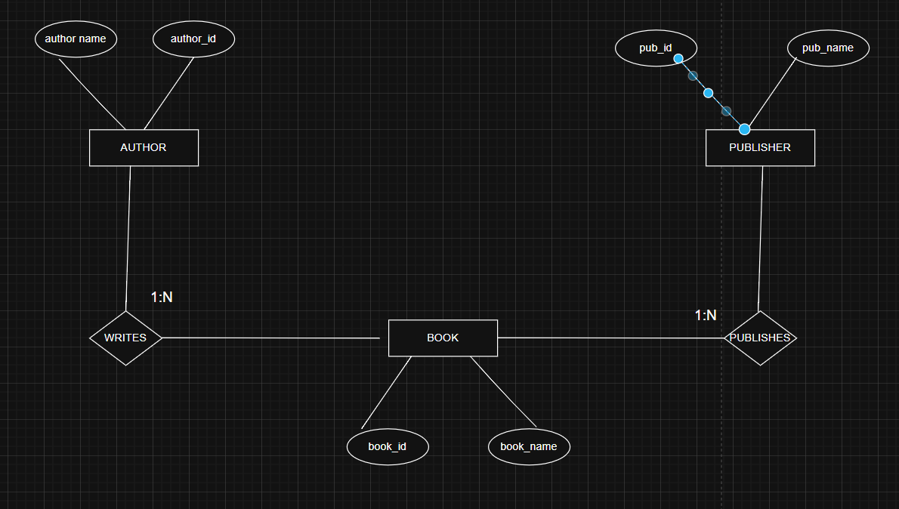

**TASK 1**

Functional Dependencies:

1. BookID → book_name, AuthorID, PublisherID
2. AuthorID → Name
3. PublisherID → Name

All tables have primary keys.Every non-key attribute depends only on the primary key.

Thus No transitive dependencies exist.

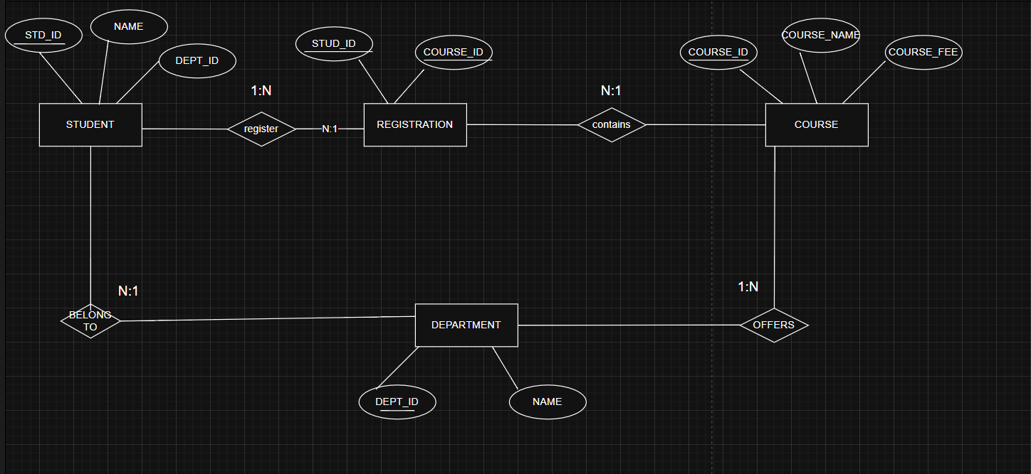

**TASK 2**

Functional Dependencies:

StudentID → Name, DeptID

CourseID → Coursename

DeptID → Name

RegID → StudentID, CourseID

3NF

Every non-key attribute depends only on the table’s primary key.every table has primary key, No partial or transitive dependencies

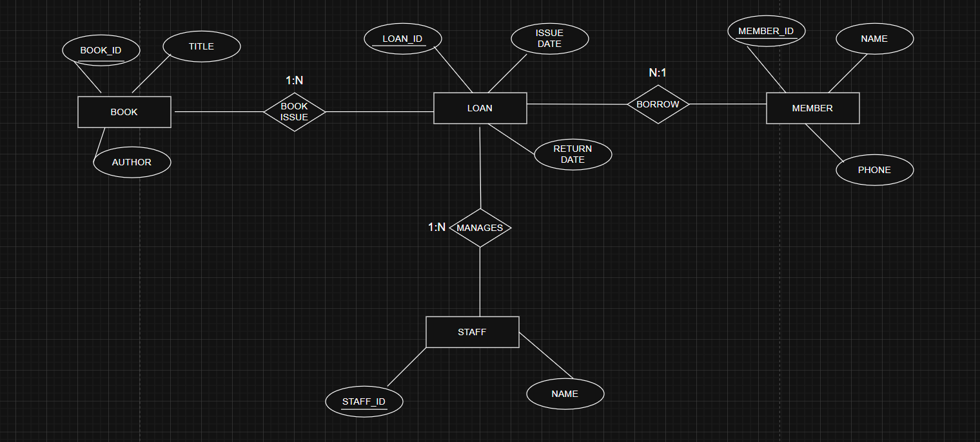

**TASK 3**

Functional Dependencies:

BookID → Title, Author, Publisher

MemberID → Name

StaffID → Name,

LoanID → BookID, MemberID, StaffID, IssueDate, ReturnDate

3NF

Each table has a single primary key.All attributes are fully dependent on that key.so no transitive dependencies.